Metrics:

* Task must be completed in an easy and efficient manner
  + How fast can users create some arbitrary sentence?
* Design of site must facilitate understanding of task objects without words
  + How well can the users understand icon meanings?
  + How many clicks do the users use before finding an icon they want?
  + How well do the users understand sentences crafted from icons?
* Users must be able to operate site without prior computer knowledge
  + How much time does it take for users to find an icon?
  + How well does the user intuit the site’s operations
* Site must allow for almost any kind of sentence to be crafted (many/any fallacy?)
  + How many icons are available?
  + How many icons can be related to a single icon?
  + How large of a sentence can the user create? (IE, how many icons can they use maximum)
  + What kind of adjectives are actually available? Is it just colors, or are there patterns as well. (for example)
* Site must allow for any user to have many chains of conversations
  + How many active conversations are allowed?
* Users must be able to easily manipulate sentences in production
  + How easy is it for users to add words and adjectives?
    - How many clicks?
    - Time?
  + How easy is it for users to delete adjectives and words?
    - Can users delete individual adjectives and words without modifying anything else?
    - How long does it take to delete things?
  + How easy is it for users to delete entire sentences?
    - Can it be done accidentally?
    - Does it confirm user intent?
  + How easily can users create new drafts?
* How easily can users find and talk to other users?
  + How long does it take to find a correspondent?

Layout uniformity metric:

$$LU=100*(1-\frac{(N_{h}+N_{w}+N_{t}+N_{l}+N_{b}+N_{r})-M}{6*N_{c}-M})$$

Where Nc is the total number of visual components on screen, dialogue box, or other interface component. Nh, Nw, Nt, Nl, Nb, and Nr are, respectively, the number of different heights, widths, top-edge alignments, left-edge alignments, bottom-edge alignments, and right-edge alignments of visual components.

$$M=2+2*[2\sqrt{N_{components}}]$$

For our layout, displayed here:

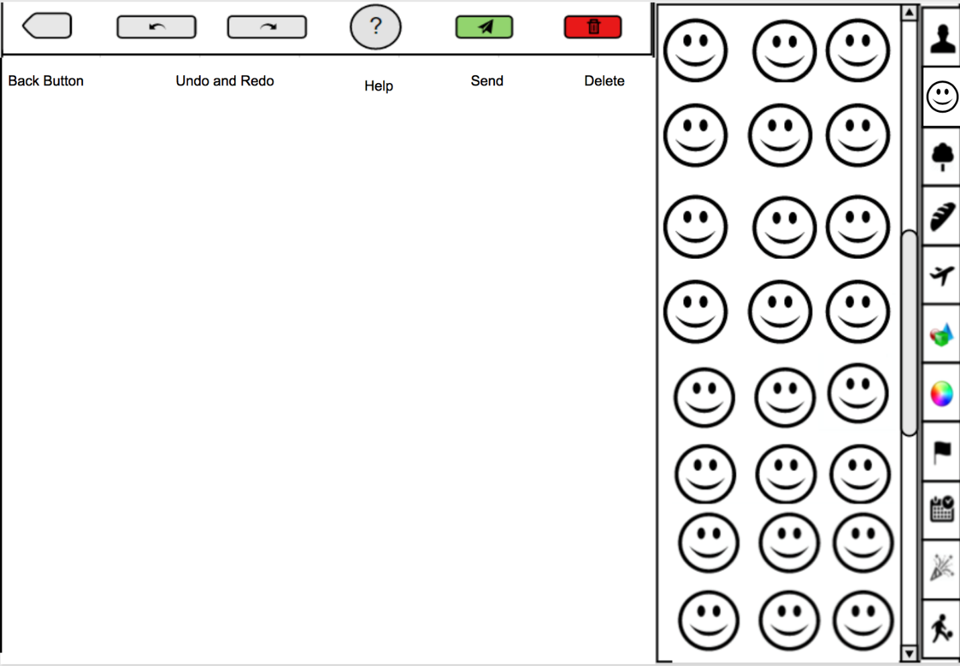

The values for the equation are as follows:

* Nh = 6
* Nw = 6
* Nt = 11
* Nl = 22
* Nb = 5
* Nr = 20
* Ncomponents = 42

Therefore, the M value can be calculated as:

$$M=2+2*[2\sqrt{42}]= 2+2*[6.481]=25.923$$

And the Layout Uniformity can be calculated as:

$$LU=100*(1-\frac{(6+6+11+22+5+20)-25.923}{6*42-25.923})=100*(1-\frac{70-25.923}{226.077})=100*(1-\frac{44.077}{226.077})=80.50\%$$

For the Task Visibility, there are a total of five distinct user tasks that will be analyzed:

1. Sending sentence
2. Deleting sentence
3. Adding single icon or adjective
4. Deleting single icon or adjective

For each of these tasks, the visibility metric is determined through the equation:

$$TV=100*(\frac{1}{S_{total}}*\sum_{i}{}V_{i})$$

Where Stotal is the total number of enacted steps to complete a use case and Vi is the feature visibility (from 0 to 1) of each enacted step i.

Sending sentence:

|  |  |  |
| --- | --- | --- |
| Enacted Step | Type | Visibility |
| Press and hold the send button | Direct | 1 |
| TV = 100% |  | Total: 1 |

Deleting sentence:

|  |  |  |
| --- | --- | --- |
| Enacted Step | Type | Visibility |
| Press and hold the delete button | Direct | 1 |
| TV = 100% |  | Total: 1 |

Adding icon or adjective:

|  |  |  |
| --- | --- | --- |
| Enacted Step | Type | Visibility |
| Select necessary category | Suspending | 0.5 |
| Scroll to the wanted icon | Exposing | 0.5 |
| Select and drag icon from icon bin onto board | Hidden | 0 |
|  |  | Total: 2 |

Deleting icon or adjective:

|  |  |  |
| --- | --- | --- |
| Enacted Step | Type | Visibility |
| Drag icon from sentence into icon bin | Hidden | 0 |
| TV = 0% |  | Total: 0 |

Total TV for all actions:

|  |  |  |  |
| --- | --- | --- | --- |
| Task | Number of steps | Total step visibility | Visibility associated with task |
| Sending sentence | 1 | 1 | 100% |
| Deleting Sentence | 1 | 1 | 100% |
| Adding icon or adjective | 3 | 2 | 66.66% |
| Deleting icon or adjective | 1 | 0 | 0% |